

NOTRE DAME UNIVERSITY
BANGLADESH
CSE-3206 Lab Report-02

Course Title: Operating System Lab
Course Code: CSE-3206

Submitted by:
Name: Istiak Alam
ID: 0692230005101005
Batch: CSE-20
Submission Date: 06-02-25
Lab Task Topic : Solve Shell Programming problems.

Submitted to:
Khorshed Alam
Lecturer, NDUB

Problem No. 01:
By using if-else find the largest number among 3 numbers.
Code :
#!/bin/bash

echo "Enter first number: "
read num1
echo "Enter second number: "
read num2
echo "Enter third number: "
read num3

if [ $num1 -ge $num2 ] && [ $num1 -ge $num3 ]; then
echo "The largest number is: $num1"
elif [ $num2 -ge $num1 ] && [ $num2 -ge $num3 ]; then
echo "The largest number is: $num2"
else
echo "The largest number is: $num3"
fi

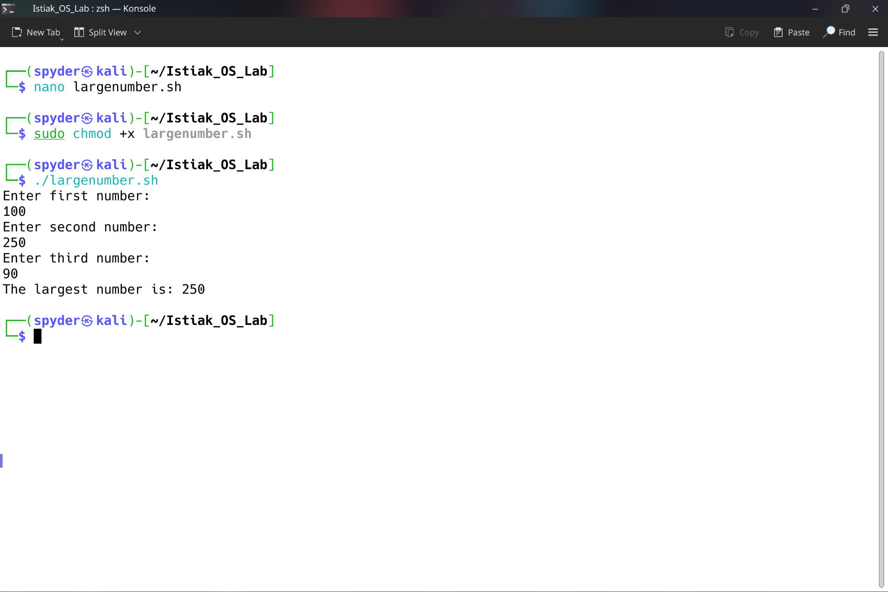
Input / Output :

Figure-1 largest number using if-else

Problem No. 02:
By using if-else find the smallest number among 3 numbers.
Code :
#!/bin/bash

echo "Enter first number: "
read num1
echo "Enter second number: "
read num2
echo "Enter third number: "
read num3

if [ $num1 -le $num2 ] && [ $num1 -le $num3 ]; then
echo "The smallest number is: $num1"
elif [ $num2 -le $num1 ] && [ $num2 -le $num3 ]; then
echo "The smallest number is: $num2"
else
echo "The smallest number is: $num3"
fi

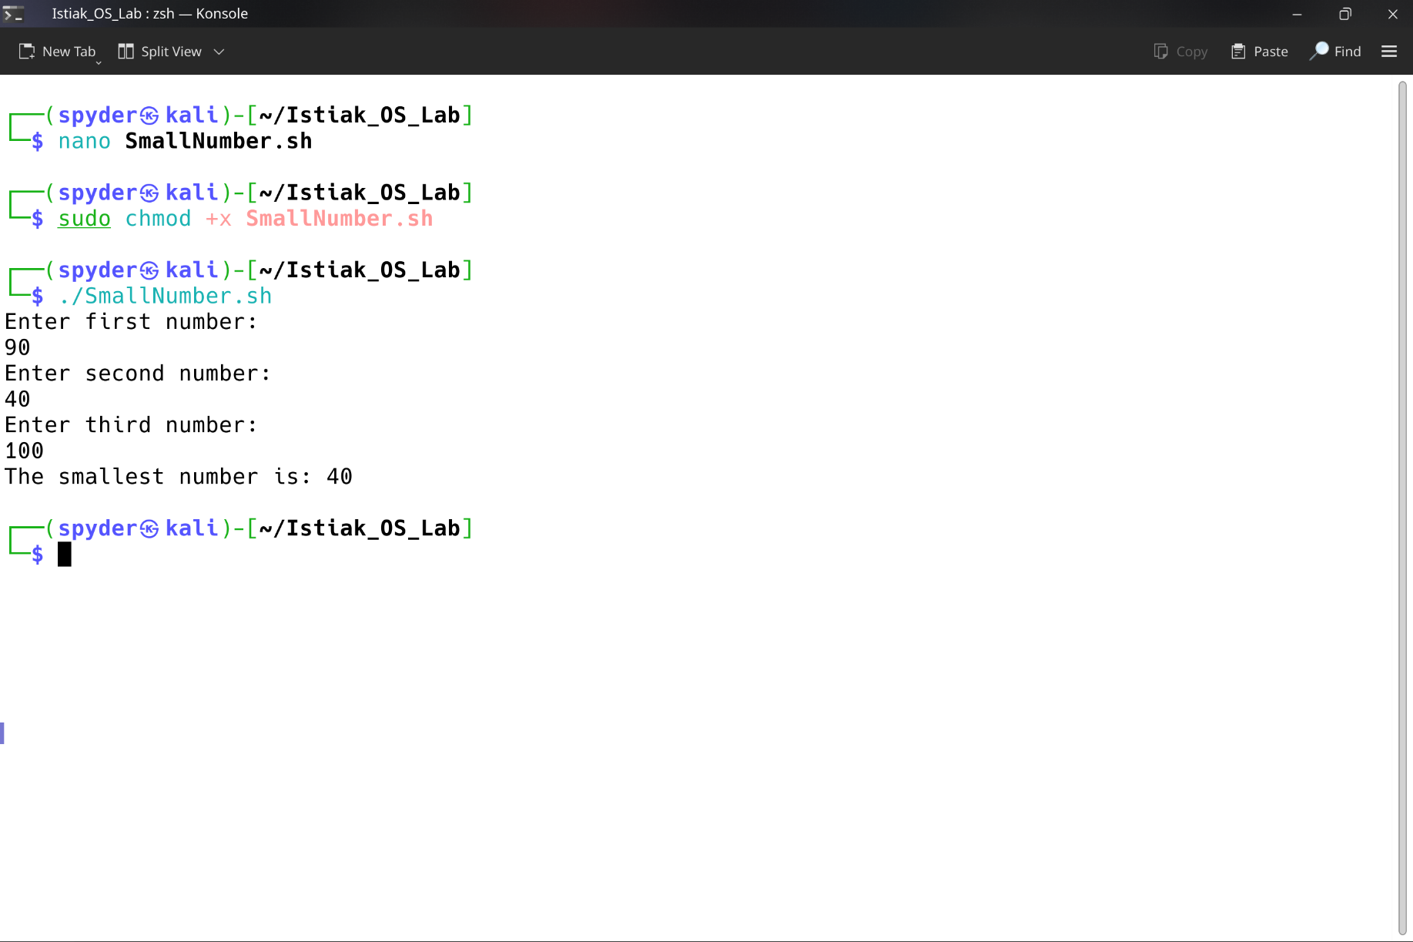
Input / Output :

Figure-2 Smallest number using if-else

Problem No. 03:
By using for-loop find the largest number among 3 numbers.
Code :
#!/bin/bash

echo "Enter first number:"
read num1
echo "Enter second number:"
read num2
echo "Enter third number:"
read num3

largest=$num1

for num in $num2 $num3
do
if [ "$num" -gt "$largest" ]; then
largest=$num
fi
done

echo "The largest number is: $largest"

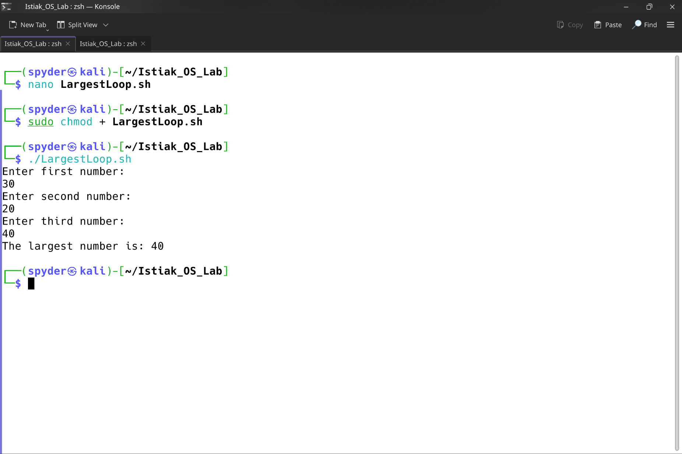
Input / Output :

Figure-3 Largest number using for-loop
Problem No. 04:
By using for-loop find the smallest number among 3 numbers.
Code :
#!/bin/bash

echo "Enter first number:"
read num1
echo "Enter second number:"
read num2
echo "Enter third number:"
read num3

smallest=$num1

for num in $num2 $num3
do
if [ "$num" -lt "$smallest" ]; then
smallest=$num
fi
done

echo "The smallest number is: $smallest"

Input / Output :
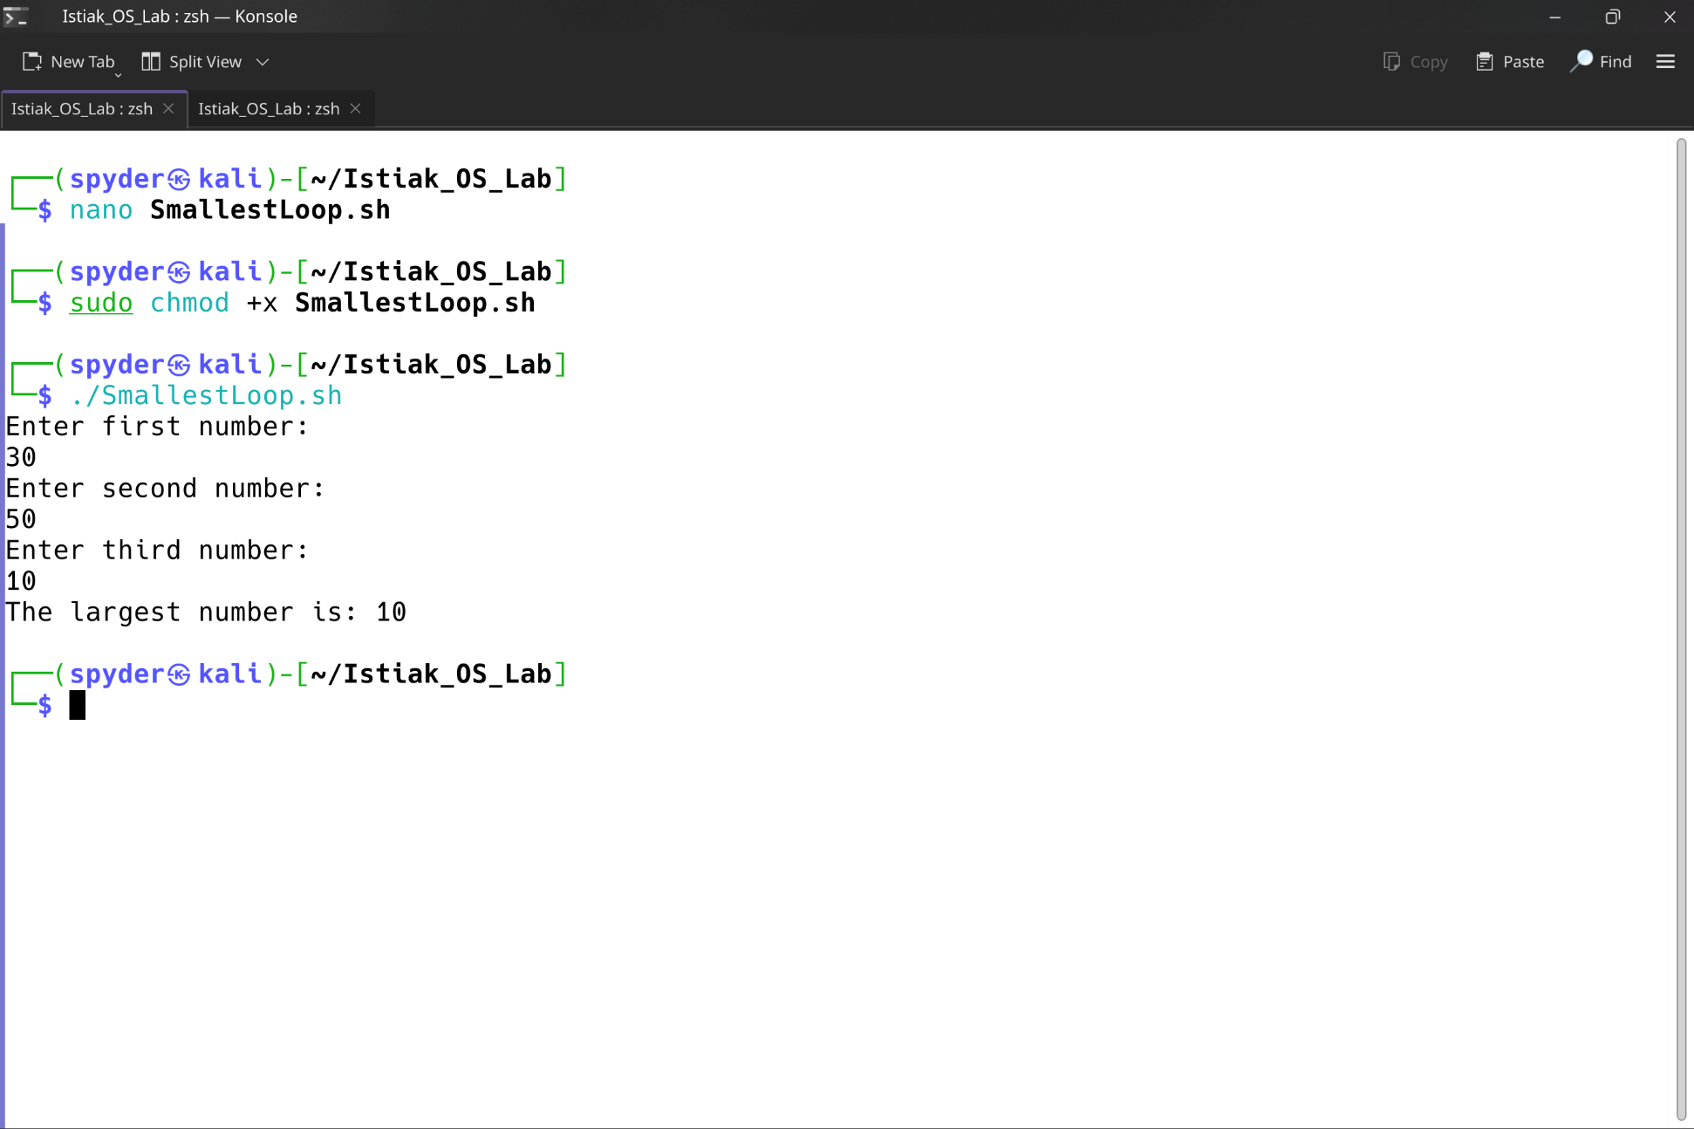

Figure-4 Smallest number using for-loop

